**DAILY ONLINE ACTIVITIES SUMMARY**

|  |  |  |  |  |  |  |  |  |
| --- | --- | --- | --- | --- | --- | --- | --- | --- |
| Date: | 03/06/2020 | | | | | Name: | Jyothi B R | |
| Sem & Sec | IV-A | | | | | USN: | 4AL18CS030 | |
| Online Test Summary | | | | | | | | |
| Subject | | Object Oriented concepts | | | | | | |
| Max. Marks | | 14 | | Score | | | 30 | |
| Certification Course Summary | | | | | | | | |
| Course | Programming Essentials in Python | | | | | | | |
| Certificate Provider | | | Cisco Virtual Academy | | Duration | | | 2.5hrs |
| Coding Challenges | | | | | | | | |
| Problem Statement. Write a Java program to find Last Digit of a^b (a to the power b) for Large Numbers | | | | | | | | |
| Status:Completed | | | | | | | | |
| Uploaded the report in Github | | | | | Yes | | | |
| If yes Repository name | | | | | https://github.com/alvas-education-foundation/jyothi_b_r | | | |
| Uploaded the report in slack | | | | | Yes | | | |

Online Test Details: (Attach the snapshot and briefly write the report for the same)

Certification Course Details: (Attach the snapshot and briefly write the report for the same)

Coding Challenges Details: (Attach the snapshot and briefly write the report for the same)

**ONLINE TEST DETAILS**: -

The online test was from module 2 and module 3. There were 30 questions which contains programing questions and the duration were 40 minutes. The questions were optimal and little complex. But the given time is not so sufficient for the program. The score that I received was 14/30.

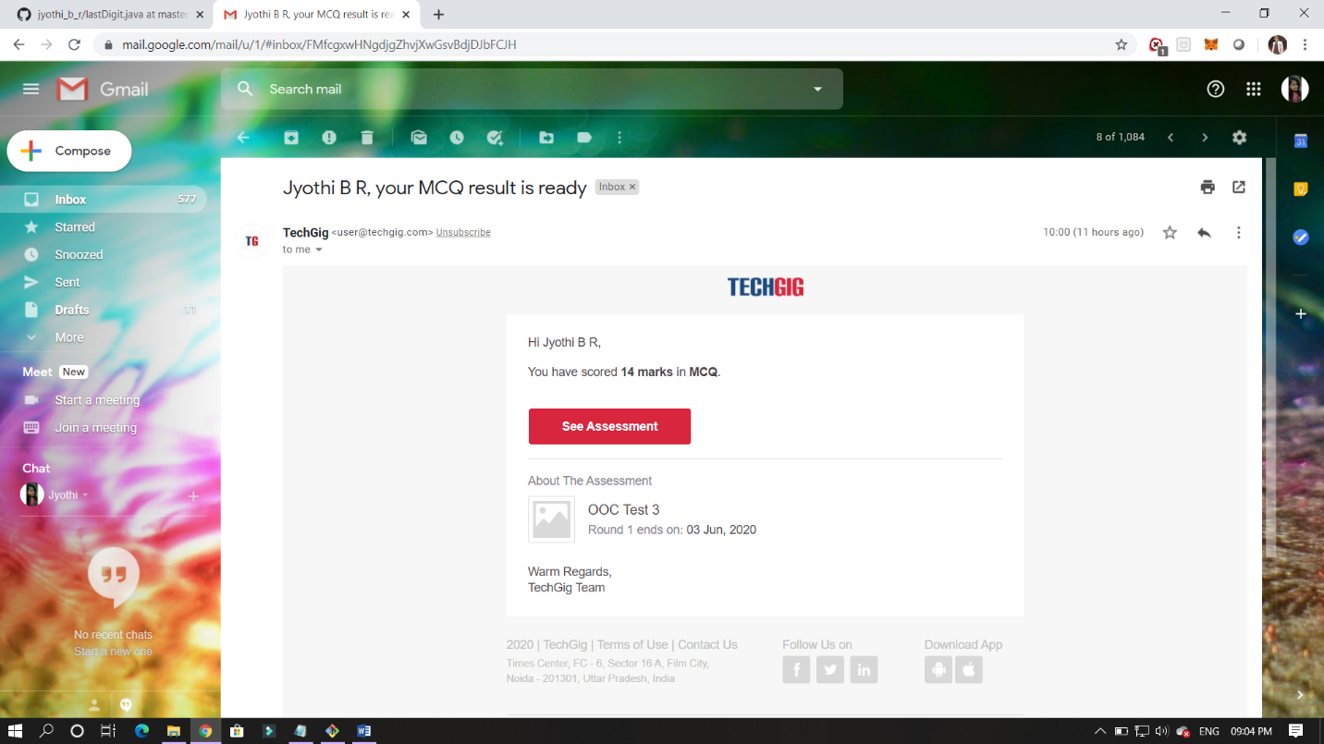

CERTIFICATION COURSE DETAILS:

Programming Essentials in Python :

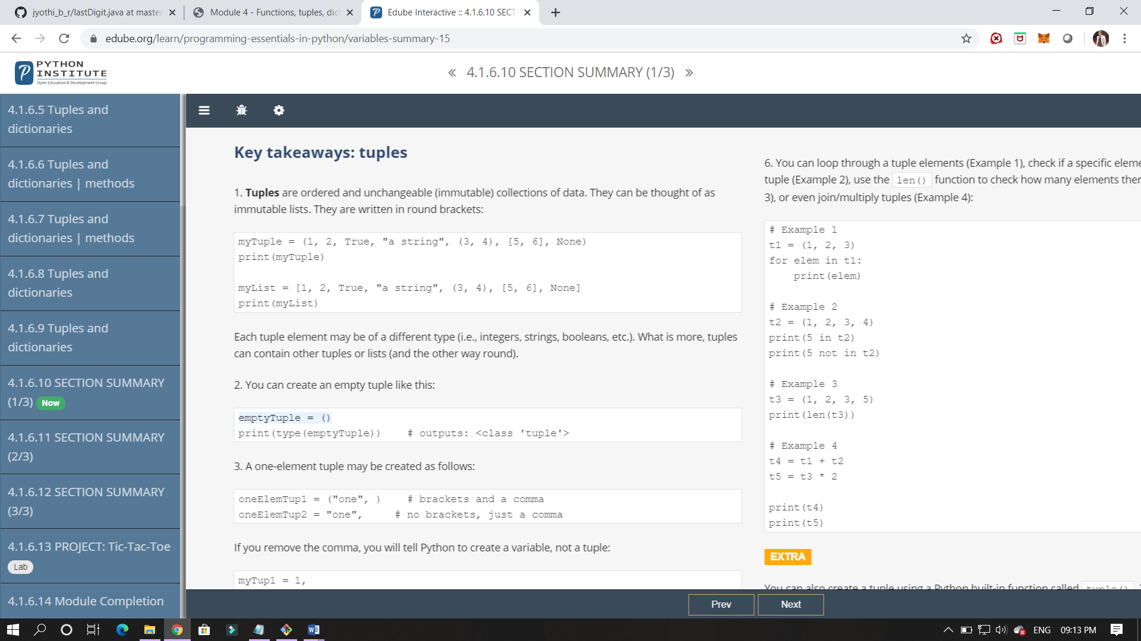

In this class I have studied about tuples and to classify it and some of its applications.

Here it is end of this module. In this module I have learned about function , parameterised function, list , tuples and dictionary . and the scope of its function where we can use it all this are studied in this module.

ONLINE CODING:

You are given two integer numbers, the base a (number of digits d, such that 1 <= d <= 1000) and the index b (0 <= b <= 922*10^15). You have to find the last digit of a^b.

Examples:

Input : 3 10  
Output : 9

